Beyond Tabular Fairness: Unified Bias Mitigation for Vision, Language, and AI Systems

Origin of the Proposal

AI-powered decision-making systems have become more prevalent in making decisions that have a direct impact on the lives of people in areas such as screening employment applications, diagnostic processes in medicine, welfare allocation, and assessing credit risk. Although they bring considerable efficiencies to decision-making processes, they are usually accompanied by inherent biases that result in discrimination against people based on sensitive characteristics like sex, race, and age. There is an urgent need to tackle this challenge.
There have been some significant advances in the area of existing literature on fairness, especially in terms of structured data. Yet, data comes in many forms. It would be wrong to focus only on the most straightforward examples of how biased algorithms might emerge; there are many types of data beyond tables that are relevant today. A hiring algorithm looking at the text of applicants’ resumes, a healthcare platform analyzing medical images, or a platform moderating social media – these can all be biased as well.
This proposal outlines a research program to develop model-agnostic frameworks for bias mitigation across three core data modalities: tabular data, natural language text, and images. Building on prior work in structured data fairness, the proposed research extends bias detection and mitigation to computer vision and natural language processing (NLP) pipelines. The goal is to develop practical, broadly applicable methods that improve fairness without significantly sacrificing predictive performance, and that can be adopted across different model architectures and application domains.

Introduction

Machine learning over the last few decades has shifted from the laboratory environment to practical applications. Algorithms currently determine who qualifies for credit, who becomes a candidate for an interview for employment, the course of treatment that should be used in medicine, and also determine one’s period in jail time. It is of paramount importance that these models show fairness in their behavior, meaning that they do not systematically discriminate against anyone in society depending on gender, race, age, or ethnicity.
Unfortunately, bias in ML systems is not rare. It has been documented across a wide range of domains and data types. Recruitment tools have been found to favour male candidates over equally qualified women. Sentiment analysis systems have assigned more negative scores to text involving minority communities. Facial recognition software has shown significantly

higher error rates for darker-skinned individuals compared to lighter-skinned ones. These are not hypothetical risks — they are real harms that have already occurred in deployed systems.
Some of the factors that contribute to such discrimination include but are not limited to: The training data may contain disparities from the past, and the model trained on that data will end up perpetuating such biases. In cases where the attributes that could lead to bias (such as race and gender) are excluded from the data, the machine-learning algorithm may end up utilizing correlated attributes instead. Class imbalances where there is less data for minority classes lead to discrimination against minorities.
Research on algorithmic fairness has produced a growing set of techniques to detect and mitigate these issues, including pre-processing methods that adjust training data, in-processing approaches that modify the learning objective, and post-processing methods that correct model outputs. Frameworks such as AI Fairness 360 [1] have made many of these tools accessible.
However, a significant gap remains. The vast majority of fairness work has focused on tabular data — structured rows and columns of numerical or categorical features. Yet modern applications are equally reliant on unstructured data: free-form text in NLP pipelines and pixel-based images in computer vision systems. Bias in these modalities is just as consequential but far less studied in a systematic way. An NLP-based re´sume´ screener might learn to associate certain writing styles or name patterns with specific demographic groups. An image classifier used in medical imaging might perform inconsistently across patient groups with different skin tones or body types.
This research addresses that gap. The proposed work aims to develop fairness frameworks that are practical, model-agnostic, and applicable across all three major data modalities — tabular data, text, and images. The central idea is that bias is not just a property of a particular model or dataset, but a structural challenge that must be addressed throughout the ML pipeline, regardless of the form the data takes.

Why Fairness Across Modalities Matters

Each data modality presents its own fairness challenges:

- Tabular Data: Bias often stems from class imbalance, biased labels, or proxy variables
— features that correlate with sensitive attributes even after those attributes are removed. Methods like reweighing, SMOTE-based augmentation, and situation testing have been explored, but most still focus on quantity over structure.
- Text (NLP): Language models can reflect and amplify societal stereotypes embedded in large text corpora. Words, names, and sentence structures carry demographic signals that models can exploit. Bias in NLP is particularly difficult to detect because it can be subtle and context-dependent.

- Images (Computer Vision): Visual models can exhibit bias when training datasets are not representative — for example, if a face recognition system was predominantly trained on images of lighter-skinned individuals, it will be less accurate for darker-skinned indi-viduals. Bias can also arise from how images are labelled and how objects or people are framed.

A unified, cross-modal approach to fairness does not currently exist. This research takes a step towards filling that void.

Scope of This Proposal

This proposal covers three interconnected research thrusts:

- Tabular Data Fairness — designing a novel method to address distributional shift, data quality validation, and structural alignment of subgroup distributions in feature space. (Work in this area is already underway.)
- NLP Fairness — Designing pre- and in-processing techniques to detect and reduce de-mographic bias in text classification and generation pipelines.
- Computer Vision Fairness — Developing methods to identify and mitigate representa-tion and label bias in image-based classification tasks, with attention to sensitive visual attributes.

Together, these efforts constitute a model-agnostic fairness framework — one that does not assume a specific architecture or algorithm, but provides tools that can be applied broadly across different ML systems and deployment contexts.
motivation
Motivation
The motivation for this research arises from two directions: the practical urgency of the problem and the clear gaps in the existing literature.

Objectives of the Proposal

The overarching goal of this research is to develop practical, model-agnostic frameworks for detecting and mitigating bias in machine learning systems across three data modalities: tabular data, text, and images. The specific objectives are as follows:

- Develop tabular fairness methods. Design a pipeline to address challenges like dis-tribution shift from train to test data, structural consistency between the subpopulation

feature distributions, and the validation of quality of synthetic samples created. The goal here is to develop a pipeline for tabular fairness which can be used as a methodology for the other two modalities.
- Develop bias detection and mitigation techniques for NLP pipelines. Identify the ways that demographic bias can arise during the process of text classification as well as other NLP tasks, and design pre-processing and in-processing strategies for mitigating such demographic biases. These may include techniques such as word embedding debi-asing, counterfactual augmentation of the training dataset, and realistic evaluation with multiple protections.
- Design fairness-aware approaches for computer vision tasks. Explore biases arising from the training data in the image classification pipeline, including imbalanced training data, biased annotations, and correlation between the learned features and visual sensitive attributes, and propose techniques to mitigate such problems through methods like data augmentation driven by fairness constraints.
- Ensure model-agnostic applicability. Any method that is proposed must be such that it functions independently of any underlying architecture. Whether a person uses a decision tree, deep learning, or even a pretrained transformer, there must be something that can be implemented on top of the framework that provides fairness benefits.
- Evaluate across multiple fairness metrics and real-world datasets. Validate the pro-posed approaches with well-established fairness measures such as Statistical Parity Dif-ference (SPD), Equal Opportunity Difference (EOD), Average Odds Difference (AOD), and Disparate Impact (DI) on various benchmark data sets for both modalities. It is also important to take into account the relationship between fairness and performance in evaluating the proposed techniques.
- Investigate cross-modal transfer of fairness strategies. Consider how methods in-vented for one modality could inspire methods in another. For example, the use of situa-tion testing for table-based data might have parallels in language data (with counterfac-tual sentence construction) and images (with attribute flipping).
- Produce open and reproducible tools. Package the new methodologies in an easy-to-use format with proper documentation to allow them to be used and tested by the wider scientific community and, when relevant, applied scientists developing practical systems.

State-of-the-Art Review

Recent Related Work

    - Tabular Data Fairness

Fairness in machine learning is becoming a field of study that is increasingly receiving attention in the last few years, particularly when it comes to tabular data in application areas like health-care, finance, education, and recruiting. Several strategies have been developed to minimize the bias in machine learning algorithms.
One of the widely used frameworks is AIF360 [1], introduced by IBM, which provides several tools and algorithms for measuring and mitigating bias in machine learning systems. Earlier studies also explored methods for identifying biased features and removing unfair influ-ence from training data. Several data balancing approaches have been proposed for fairness im-provement. FairSMOTE [2] extends the traditional SMOTE algorithm by generating synthetic samples for underrepresented groups, helping improve fairness and class balance together. Mir-rorFair [3] creates balanced datasets by generating mirrored samples through changes in pro-tected attributes while keeping other features similar. FairMask [4] follows a different strategy by masking protected attribute information during model training so that the model learns less biased patterns without generating synthetic data.
More recent works such as FairGenerate [5] and FairPreprocessor [6] focus on reducing bias through situation testing and preprocessing techniques before model training. These methods highlight the importance of handling biased labels and imbalanced data at an early stage of the pipeline. Another important approach is Correlation Tuning (CoT-phi) [7], which reduces bias by adjusting the relationship between protected attributes and target labels while maintaining a balance between fairness and performance. Though the existing techniques have yielded encouraging outcomes, there is an inherent problem with the creation of high quality synthetic data that mirrors the real data set but is free from any noise or bias. The solution for the same involves using fairness testing and controlled generation of synthetic data.

    - Computer Vision Fairness

Chuang et al. [8] proposed debiasing vision-language models by projecting out biased di-rections from CLIP’s text embeddings using calibrated projection matrices built from natural language prompts. However, this method is tied to the text-image architecture of CLIP and cannot be applied to standard image classifiers such as CNN or ViT. Tian et al. [9] introduced FairViT, which deploys group specific masks of attention layers of vision transformer. These masks are updated iteratively during training. This method also uses a distance loss in place of standard categorical cross entropy. But, this method is made for attention mechanism of ViTs,

so it can not be applied to CNN based Pipelines. FairViT also requires sensitive information like gender to assign masks during training, which raises privacy concerns in clinical or legal settings. Manzoor and Rattani[10] proposed FineFACE, reframing facial attribute classifica-tion as a fine-grained recognition problem using cross-layer mutual attention learning across shallow-to-deep CNN experts. While FineFACE achieves impressive bias reduction without requiring protected attribute, its multi-step mutual learning strategy significantly extends train-ing time and couples the method tightly to CNN architectures with specific stage-grouping requirements, limiting its transferability to transformer-based models. Patel and Kisku [11] addressed bias through a combination of dual attention and a KL divergence regularised loss function with an intra-class Mahalanobis distance term. While this loss-level intervention is relatively model agnostic, this method still needs demographic group information to compute distance between classes during training, and its performance degrades on the BFW dataset due to limited diversity present in the dataset, which raises concerns about generalisation outside benchmarks. Ka¨rkka¨inen and Joo [12] developed FairFace, a racially balanced face dataset sampled from Flickr with country level demographic weighting which reduces reprasentation bias. But dataset rebalancing alone cannot correct label level bias introduced by opinions and prejudices of annotator’s and this method provides no mechanism for handling biased labels. Luo et al. [13] proposed FairCLIP, using optimal transport to minimise Sinkhorn distance be-tween overall and group specific feature distributions during VL model pretraining on medical fundus images. This method requires pretraining large vision-language models from scratch on specialized paired datasets, which is computationally expensive, and it also requires protected attributes. A shortcoming shared across all reviewed works [8][9][10][11][12][13]is their fail-ure to address label-level bias. Every method assumes that training labels faithfully represent ground truth and focuses correction efforts at the model, feature, or dataset distribution level. Architecture specific techniques and protected attribute dependence collectively motivates the need for a model-agnostic frameworks that operates without protected attributes at deployment. So this work aims to propose a model agnostic framework that doesn’t depend on architecture or sensitive information.

    - NLP Fairness

Language processing bias has become increasingly recognized as a problem within NLP appli-cations, which have been applied for use in applications ranging from hiring to content filtering and sentiment analysis. Previous research into this issue has largely concentrated on English language data and on biases that are prominent in Western culture, including issues related to gender and race stereotypes. Although this research was significant, it omitted much of the globe, which exhibited different forms of social biases.
One of the earliest pieces of work in this area includes that by Malik et al. [14], where they studied Hindi representations for bias. In this study, they found that there were signifi-

cant levels of biases such as caste and religious biases, and these biases have been influenced heavily by history and culture in the region. Further, they discovered that biases like gender bias which have been present in English language data, take a different form altogether in the Hindi language. One of the early pieces of work in the field to indicate that fairness methods for English do not apply for Indian languages. Following this line of thought, Khandelwal et al. [15] proposed Indian-BhED, the first dataset that is specifically designed to assess caste and religion biases in LLMs for the Indian setting. Various popular LLMs were evaluated using this method and they were found to overwhelmingly produce stereotypical outputs based on Indian prompts. What made their work especially interesting was the fact that the bias level they found was much more for the case of India’s own societal divides such as caste and religion compared to any other factor in Western countries like race and gender. For an easy solution, they tried instruction prompting and it was found to have some success in reducing stereotypical outputs.
After this, Sahoo et al. [16] presented IndiBias, which is a benchmarking dataset released in NAACL 2024. This dataset is related to seven axes of social inequality in India, such as caste, religion, gender, and region. It comprises 800 sentence pairs and 300 tuples in both En-glish and Hindi. The authors evaluated the performance of ten language models using various bias-related metrics. They observed that bias in intersectional categories like caste and gender was higher than that in individual categories. Still, IndiBias addresses only bias detection, not mitigation. The latest literature relevant to this topic is DECASTE by Vijayaraghavan et al.
[17] published at IJCAI 2025. This paper presented a multi-dimensional approach to identify explicit and implicit biases regarding caste in LLMs. These four dimensions include social-cultural, economic, educational, and political aspects. The authors used two categories of test: first, a type of test which evaluates the word associations with caste groups; secondly, a sce-nario test in which LLMs act in a situation involving caste personas. They found that these models consistently rated responses from dominant caste groups as favourable compared to marginalised caste communities such as Dalits with differences up to 25%. Once again, this paper only addressed detection and evaluation and did not propose any mitigations.
From all the papers analyzed above, it is possible to see the emergence of some trend. The literature on this topic has been able to clearly show that caste and religious prejudice exists in LLMs and it is important to tackle this issue. Yet, none of the research papers have managed to suggest any methodology for tackling this issue, let alone giving a model-agnostic methodology for it. The ways in which this bias is being reduced through instruction prompting, for example, is much less formalized and is not consistent throughout. At last, the methods used to mitigate the bias do nothing more than checking for the bias after it has occurred but not if the bias already exists in the labeling process.

Novelity

While existing bias mitigation frameworks are typically designed for a specific data modality, our pipeline introduces a modality agnostic architecture that unifies preprocessing, detection, filtering, and augmentation-based correction across computer vision, natural language process-ing, and tabular datasets. Unlike prior approaches that apply bias correction as a one-time, post hoc operation, this framework includes an iterative feedback mechanism directly into the pipeline. When equalized parity is not achieved following an augmentation pass, the data is automatically rerouted through the bias detection and correction stages. This closed loop design ensures that fairness is not assumed after a single intervention but is instead verified and enforced at each iteration until the convergence criterion is satisfied. Rather than rely-ing on modality-specific fairness metrics that shift in definition depending on the nature of the input data, the proposed pipeline standardizes evaluation through a unified parity-based criterion. This design choice eliminates inconsistencies that arise when different metrics are applied across different data types, ensuring that fairness is measured on equal terms regard-less of whether the underlying data consists of image features, text embeddings, or structured numerical attributes. In contrast to existing tools such as AIF360 and Fairlearn, which were primarily developed and validated for structured tabular data, this pipeline has been designed from the ground up to generalize across multiple data modalities.

Work Plan

Methodology

The proposed research develops three bias-mitigation methods, each designed for a different data modality. Although the techniques differ in their implementation, all three approaches follow a common iterative framework, illustrated in Figure 1. The first phase of the pipeline involves the preprocessing of the data, wherein the raw data is prepped and transformed to a form that can be analyzed. The purpose of this phase is to make sure that there is consistency in the data set.
Following the preprocessing step, the process will then move towards the detection of bias, wherein the dataset will be scanned for any possible form of demographic, representation, and distribution bias. Bias that has been detected will then be filtered out through a bias filter.
Once the dataset is cleaned, it goes through equality parity checking, which determines whether the fairness criteria have been met among all groups. If the dataset fails to satisfy the fairness criteria set by the system, the model undergoes a corrective loop process, where data augmentation is used to balance out the representational inequality. Once augmented, the data will be returned to the previous stages to detect biases and filter out unfairness.
Once the dataset passes through the threshold of equal parity, the optimized and balanced data



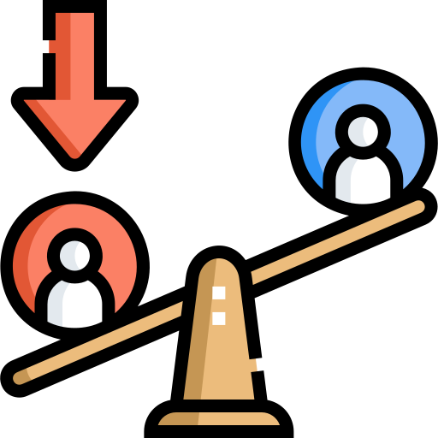

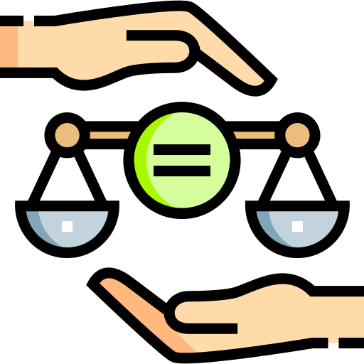
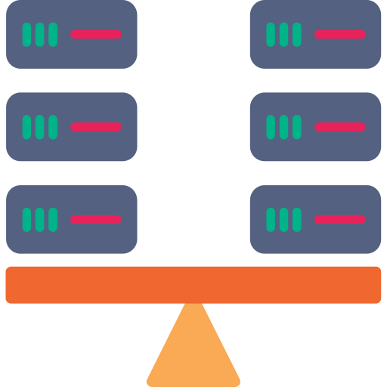
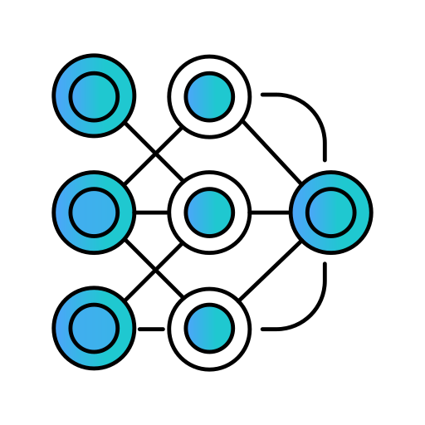
Bias Filter

Yes

Training Dataset

Data

PreProcessing Bias Detection

Equalized Parity?

Balanced Dataset

ML / AI
Model

NO

Data Augmentation Framework

Figure 1: Description of the proposed learning pipeline that is used to incorporate fairness across all three modalities. The proposed pipeline is based on an iterative procedure of data preprocessing, bias identification, filtering, fairness assessment, and augmentation, which en-sures balanced data before applying AI/ML models, hence avoiding the risk of propagating biased data into future algorithms.

is then used for training the appropriate AI/ML model. This pipeline guarantees continuous improvement in fairness before the training of models to minimize biases in decision-making by the final AI/ML system.

    - Method 1: Bias Mitigation for Tabular Data

The pipeline, shown in Figure 2, is designed to improve both fairness and data balance in tabular datasets. The methodology combines two main stages: Situation Testing and Data Balancing through Synthetic Data Generation.
In the first stage, the original dataset is used to train an initial classification model. To iden-tify potentially biased data points, the same data is evaluated twice: once in its original form and once after modifying the protected attribute values (such as gender or race). If the pre-diction changes significantly after this modification, the corresponding instance is considered sensitive to bias and is removed from the training data. This forms the first level of Situa-tion Testing, helping reduce unfair influence before the balancing process begins. The filtered dataset is then used to train a second classification model for later fairness verification.
Next, the dataset is divided into smaller groups based on protected attributes and target classes. For example, if the protected attribute is gender and the target contains favorable and unfavorable outcomes, the data is separated into four subsets corresponding to each combina-tion. The largest subset is identified, and the remaining subsets are balanced by generating additional synthetic samples until all subsets reach a similar size. This stage forms the Data

Balancing component of the framework.
The process of generating data synthetically is done independently on each individual sub-set. In order to preserve data quality, statistical distances will be used to exclude outliers when generating data. The data points that represent the majority of the data are selected, and neigh-bor based learning techniques can be used for synthesizing new instances.
The model utilizes adaptive interpolation approaches, considering the nature of proximity among the neighboring points, in order to create artificial instances while keeping similar char-acteristics with respect to the original distribution. In the case of categorical features, the model chooses the value based on representative samples. This balancing approach goes on until the size of the subsets becomes the same. Finally, these subsets are merged together.
To further improve fairness, the balanced dataset undergoes a second round of Situation Testing using the second classification model trained earlier. Any remaining biased instances identified during this stage are removed before final training. Finally, the refined dataset is used to train the final prediction model. The trained model is then evaluated on a separate testing dataset to measure both predictive performance and fairness. The detailed experimental results and comparison with existing frameworks on dataset(in table1) are presented in Table 2. Figure 3 shows Fairea-based effectiveness distribution for our pipeline in comparison with the Fairea baseline which is categorized into win-win, good trade-off, bad trade-off, inverted, and lose-lose region. The results are based on a total of 1,100 bias mitigation cases for each dataset. The results show that our pipeline consistently outperforms the Fairea baseline, achieving, on average, 76% of cases in the win-win and good trade-off regions whereas FairSmote and FairGenerate reports improvements in only 59% and 65% of cases respectively against Fairea baseline.








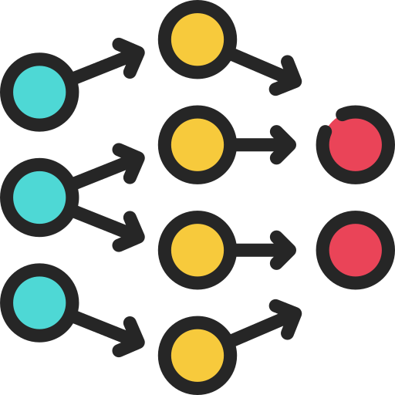



Original Dataset
Dataset
Training Dataset
Synthetic Data Generation
Classifer 3
Final Prediction
Bias Filter
Filtered Data
Bias Filter
Final Dataset

Testing

Classifer 1 Classifer 2

Figure 2: Pipeline for Mitigating Bias for Tabular Data

Table 1: Datasets used in this work

Dataset Name | Protected Attributes | Dataset Size (No.of Features)
Campus[18] | Race,Sex | 7,214 (28)
German[19] | Sex | 1,000 (59)
Heart [20] | Age | 297 (14)
Student [21] | Sex | 1,044 (33)
Bank [22] | Age | 45,211 (16)
MEPS15[23] | Race | 15,675 (139)
MEPS16 [23] | Race | 15,830 (139)
Default [24] | Sex | 30,000 (24)
Adult [25] | Race,Sex | 48,842 (14)
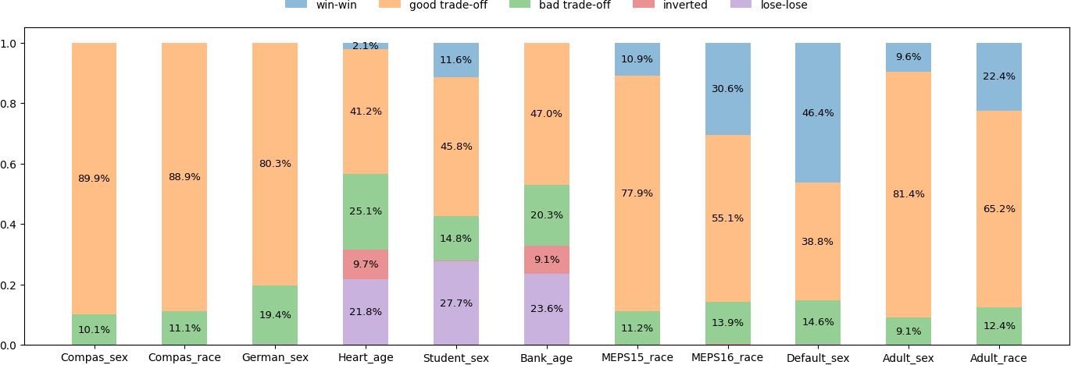
Figure 3: Distribution of tradeoff effectiveness using Fairea baseline. The proposed pipeline outperforms the Fairea baseline in 76% of cases with the max cases in win-win and good-trade off region being 89% and overall range being [43% to 89.9%]

    - Method 2: Bias Mitigation for Computer Vision Data

Overview. computer vision models are trained on large amount of image and video datasets. The problem of bias is evident within visual data collections in the context of their historical and social environments when produced and labeled. Herein, bias means that computer vision systems will do more than recognize objects. They will also recognize associations between specific groups and attributes or scenarios. This becomes a real concern in the Indian setting where skin tone, gender presentation, and regional appearance are inherent in the visual repre-sentation of people. In medical imaging many models have been found performing worse on women and old age patients. There has been no previous work that has addressed the develop-ment of a pipeline which systematically identifies, reduces, and monitors such bias across the full data collection, annotation, and model training workflow. Therefore, our pipeline presented in Figure 4 aims to address these challenges systematically.
The methodology shown in figure4 constitutes a fairness-aware, noise-robust, adaptive oversampling framework designed to maintain fairness in imbalanced datasets. we have ex-plained the methodology in detail in following points.

Table 2: Comparison of model performance and fairness metrics across datasets with classifier ’Logistic Regression’. Metrics marked with a ‘–’ indicate that lower values are preferred. Yellow color reflects the best cell and pink color reflects the second-best cell.

Dataset | Name | Recall(+) |  |  | Precision(+) |  |  | Accuracy(+) |  |  | F1 Score(+) |  |  | AOD(-) | EOD(-) | SPD(-) | DI(-)
Campus-Sex | FairSmote[2] FairMask[4] FairGenerate[5] MirrorFair[3]  FairCreate | 0.5870  0.6912  0.5922  0.6912  0.5584 |  |  | 0.6925  0.6689  0.6999  0.6709 |  |  | 0.6306  0.6452  0.6355  0.6452  0.6265 |  |  | 0.6367  0.6802  0.6460  0.6802  0.6213 |  |  | 0.0461  0.1290  0.0412  0.1290 | 0.0360 | 0.0452  0.1478 | 0.0952  0.7776
0.0893
0.0582
0.0906
 |  |  |  |  |  |  |  |  |  |  |  |  |  |  |  | 0.0282 | 0.0576
 |  |  |  |  |  |  |  |  |  |  |  |  |  |  |  | 0.1462 | 0.2227
 |  |  |  |  |  | 0.7089 |  |  |  |  |  |  |  | 0.0304 | 0.0520 | 0.0391 | 0.0918
Campus-Race | FairSmote[2] FairMask[4] FairGenerate[5] MirrorFair[3]  FairCreate | 0.5205  0.7074  0.5550  0.6991  0.5898 |  |  | 0.7058  0.6670  0.7064  0.6718  0.7028 |  |  | 0.6226  0.6466  0.6258  0.6469  0.6344 |  |  | 0.5998  0.6857  0.6178  0.6863  0.6417 |  |  | 0.0647  0.0626 | 0.0672  0.0762 | 0.0991  0.0968  0.0242  0.2290 | 0.2128  0.8494  0.0589  0.3054
 |  |  |  |  |  |  |  |  |  |  |  |  |  | 0.0422 | 0.0524
 |  |  |  |  |  |  |  |  |  |  |  |  |  | 0.2058 | 0.2038
 |  |  |  |  |  |  |  |  |  |  |  |  |  | 0.0340 | 0.0532 | 0.0234 | 0.0495
German | FairSmote[2] FairMask[4] FairGenerate[5] MirrorFair[3]  FairCreate | 0.8172  0.8806  0.7408  0.8774  0.7453 |  |  | 0.7972  0.7912  0.8418  0.7948  0.8372 |  |  | 0.7250  0.7550  0.7225  0.7525  0.7200 |  |  | 0.8063  0.8304  0.7872  0.8292  0.7879 |  |  | 0.1764 | 0.1070 | 0.0956  0.0524  0.0366  0.0617 | 0.1345  0.9310
 |  |  |  |  |  |  |  |  |  |  |  |  |  | 0.0450 | 0.0296
 |  |  |  |  |  |  |  |  |  |  |  |  |  | 0.0512  0.0650 | 0.0668 |  | 0.0577  0.0820  0.0855
 |  |  |  |  |  |  |  |  |  |  |  |  |  |  | 0.0334
 |  |  |  |  |  |  |  |  |  |  |  |  |  | 0.0595 | 0.0750 | 0.0517
Heart | FairSmote[2] FairMask[4] FairGenerate[5] MirrorFair[3]  FairCreate | 0.8062  0.8002  0.8165  0.7682 |  |  | 0.8490  0.8462  0.8038  0.8750  0.8148 |  |  | 0.8333  0.8333  0.8333  0.8333  0.8333 |  |  |  | 0.8212 |  | 0.0754 | 0.1064 | 0.1924 | 0.3796
 |  |  |  |  |  |  |  |  |  |  | 0.8172  0.8192  0.8112  0.8176 |  |  | 0.0897  0.0828  0.1153 | 0.1120 | 0.2484  0.1656  0.2627 | 0.5187  0.3326  0.4839
 |  |  |  |  |  |  |  |  |  |  |  |  |  |  | 0.0884
0.1316
0.1136
 |  |  | 0.8305 |  |  |  |  |  |  |  |  |  |  | 0.0611 |  | 0.1956 | 0.3764
Student | FairSmote[2] FairMask[4] FairGenerate[5] MirrorFair[3]  FairCreate | 0.9130  0.9151  0.9194  0.9194 |  |  |  | 0.9550 |  |  | 0.9378 |  | 0.9326  0.9312  0.9330  0.9312 |  |  | 0.0268 | 0.0386 | 0.0791  0.0751  0.0772 | 0.1718  0.8400  0.1753
 |  |  |  |  | 0.9540  0.9550  0.9550 |  |  | 0.9354  0.9354  0.9354  0.9354 |  |  |  |  |  | 0.0198 | 0.0429  0.0429
0.0209
0.0185
0.0185
 |  |  |  |  |  |  |  |  |  |  |  |  |  |  | 0.0382 | 0.0730  0.0730 | 0.1604
 |  |  | 0.9163 |  |  | 0.9551 |  |  |  |  |  | 0.9330 |  |  | 0.0453 |  | 0.1515
Bank | FairSmote[2] FairMask[4] FairGenerate[5] MirrorFair[3]  FairCreate | 0.7466  0.7090  0.7554  0.7207 |  |  | 0.7700  0.7876  0.7722  0.7835  0.7720 |  |  | 0.7763  0.7714  0.7783  0.7743 |  |  | 0.7604  0.7488  0.7643  0.7517 |  |  | 0.0121  0.0269 | 0.0151 | 0.0129 | 0.0272
 |  |  |  |  |  |  |  |  |  |  |  |  |  |  | 0.0420 | 0.0239  0.0152  0.0246 | 0.9446  0.0332  0.0542
 |  |  |  |  |  |  |  |  |  |  |  |  |  | 0.0096 | 0.0122
 |  |  |  |  |  |  |  |  |  |  |  |  |  | 0.0244 | 0.0474
 |  |  | 0.7587 |  |  |  |  |  | 0.7794 |  |  | 0.7650 |  | 0.0078 | 0.0163 | 0.0128 | 0.0269
Meps15 | FairSmote[2] FairMask[4] FairGenerate[5] MirrorFair[3]  FairCreate | 0.3422  0.4138  0.7331  0.3758 |  |  | 0.6575  0.6816  0.3995  0.6995  0.4037 |  |  | 0.8567  0.8661  0.7676  0.8654  0.7688 |  |  | 0.4487  0.5156  0.5172  0.4872 |  |  | 0.0775  0.0626  0.0211  0.0701 | 0.1359  0.0922  0.0272  0.1104  0.0284 | 0.0078 | 0.0892
 |  |  |  |  |  |  |  |  |  |  |  |  |  |  |  | 0.0878  0.0881  0.0851  0.0941 | 0.4414  0.2408  0.5823  0.2524
 |  |  | 0.7465 |  |  |  |  |  |  |  |  | 0.5256 |  | 0.0231
Meps16 | FairSmote[2] FairMask[4] FairGenerate[5] MirrorFair[3]  FairCreate | 0.2977  0.3701  0.7231  0.3032 |  |  | 0.6170  0.6542  0.3766  0.6834  0.3832 |  |  | 0.8474  0.8579  0.7464  0.8570  0.7499 |  |  | 0.4014  0.4715  0.4933  0.4228 |  |  | 0.0640  0.0501 | 0.1232  0.0648 | 0.0100 | 0.1258
 |  |  |  |  |  |  |  |  |  |  |  |  |  |  |  | 0.0893  0.1158  0.0755  0.1266 | 0.4192  0.2890  0.6130
 |  |  |  |  |  |  |  |  |  |  |  |  |  | 0.0296 | 0.0354
 |  |  |  |  |  |  |  |  |  |  |  |  |  | 0.0516 | 0.0674
 |  |  | 0.7367 |  |  |  |  |  |  |  |  | 0.5026 |  | 0.0409 | 0.0295 |  | 0.2998
Default | FairSmote[2] FairMask[4] FairGenerate[5] MirrorFair[3]  FairCreate | 0.6293  0.2434  0.6440  0.2307 |  |  | 0.3705  0.7197  0.3652  0.7214  0.3662 |  |  | 0.6812  0.8098  0.6711  0.8088  0.6700 |  |  |  | 0.4678 |  | 0.0496 | 0.0390  0.0132 | 0.0471  0.0174  0.0168 | 0.1326  0.7977  0.0442  0.1766
 |  |  |  |  |  |  |  |  |  |  | 0.3636  0.4652  0.3488 |  |  | 0.0106
 |  |  |  |  |  |  |  |  |  |  |  |  |  | 0.0232 | 0.0111
 |  |  |  |  |  |  |  |  |  |  |  |  |  | 0.0082 | 0.0146 | 0.0140
 |  |  | 0.6444 |  |  |  |  |  |  |  |  | 0.4667 |  | 0.0186 | 0.0101 | 0.0154 | 0.0403
Adult-sex | FairSmote[2] FairMask[4] FairGenerate[5] MirrorFair[3]  FairCreate | 0.7050  0.4201  0.7904  0.2844  0.7909 |  |  | 0.4914  0.6759  0.4350  0.7974  0.4321 |  |  | 0.7530  0.8108  0.7024  0.8108  0.6979 |  |  | 0.5785  0.5168  0.5611  0.4192 |  |  | 0.0170  0.0397 | 0.0266 | 0.1008  0.0888  0.0906 | 0.2651  0.5006  0.1956  0.7428
 |  |  |  |  |  |  |  |  |  |  |  |  |  |  | 0.0602
 |  |  |  |  |  |  |  |  |  |  |  |  |  | 0.0136 | 0.0329
 |  |  |  |  |  |  |  |  |  |  |  |  |  | 0.0660 | 0.1114 | 0.0856
 |  |  |  |  |  |  |  |  |  |  |  | 0.5588 |  | 0.0088 | 0.0214 | 0.0790 | 0.1688
Adult-race | FairSmote[2] FairMask[4] FairGenerate[5] MirrorFair[3]  FairCreate | 0.7365  0.4225  0.7649  0.3692  0.7713 |  |  | 0.5128  0.7052  0.4882  0.7439  0.4850 |  |  |  | 0.7688 |  | 0.6030  0.5290  0.5965  0.4934 |  |  | 0.0136 | 0.0274 | 0.0754 | 0.2143
 |  |  |  |  |  |  |  | 0.8185  0.7512  0.8108  0.7483 |  |  |  |  |  | 0.0262 | 0.0325 | 0.0602 | 0.5986  0.2203  0.4997
 |  |  |  |  |  |  |  |  |  |  |  |  |  | 0.0200 | 0.0215 | 0.0842  0.0647  0.0817
 |  |  |  |  |  |  |  |  |  |  |  |  |  | 0.0486 | 0.0710
 |  |  |  |  |  |  |  |  |  |  |  | 0.5958 |  | 0.0190 | 0.0203 |  | 0.2101

      - A Test Dataset and a Training Dataset are taken as inputs. The Training Dataset is fed into two separate Classifiers to check if the prediction is same or different.

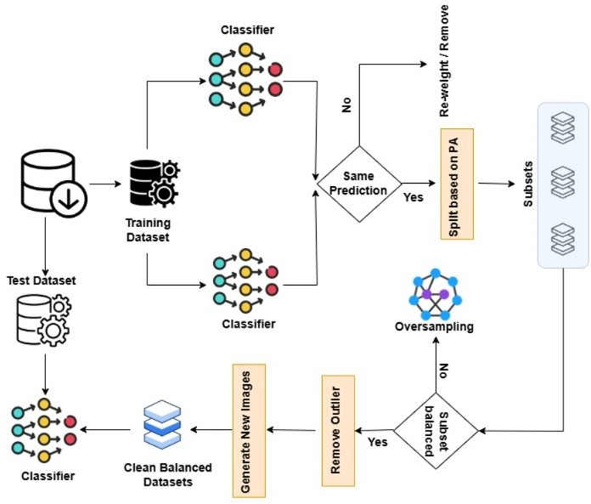

Figure 4: Computer vision Bias mitigation Pipeline

      - Both classifiers independently make predictions on the training samples.If both classifers give the same prediction the sample is considered reliably labeled and moves forward to the splitting stage. Otherwise sample is flagged as potentially noisy and re-weighted or removed from the dataset to improve data quality.
      - Samples that pass the agreement check are split into subsets based on a Protected At-tribute (PA). This produces multiple subsets for further processing.
      - After this each subset is evaluated for class imbalance. if the subset is balanced it pro-ceeds to outlier detection. If the subset is not balanced Diffusion/GAN Oversampling is applied to synthetically generate new samples and balance the subset.
      - Every sample in balanced subsets is checked for outliers. If the sample is flagged as oulier it is entirely removed from the dataset. If it is not considered an outlier it Proceeds to synthetic sample generation.
      - KNN-Based Synthetic Sample Generation : For non-outlier samples, we find the two nearest neighbors (n₁, n₂) using K-Nearest Neighbors (KNN). After that we calculate following distances.

x₁ = dist(p, n₁) (distance from point p to neighbor n₁) (1)
x₂ = dist(p, n₂) (distance from point p to neighbor n₂) (2)
x₃ = |x₁ − x₂| (absolute difference between the two distances) (3)

      - Conditional Interpolation After this for each sample a simple condition is evaluated: x₁ ≤ x₃? based on this condition we get two cases. Case 1: x₁ ≤ x₃ (Weighted Three-Point Interpolation) A weighted interpolation of the point and both neighbors is used, with weights proportional to their distances:

new = a · p + b · n₁ + c · n₂ (4) where the weights are defined as:

t = x₁ + x₂ + x₃ (5)

a = x1 , b = x2 , c = x3
(6)

t t t

Case 2: x₁ > x₃ (Two-Point Interpolation)
A simpler two-point interpolation between the original point and the nearest neighbor is applied:

new = x₃ · p + x₁ · n₁
x₃ + x₁
(7)

This adaptive formula ensures that synthetic samples are generated closer to the denser region, thereby avoiding noisy borderline areas.
      - The generated synthetic samples are combined with the cleaned original data to produce Clean Balanced Datasets. These datasets are then used to train a final Classifier, which is evaluated on the original Test Dataset.

Datasets. This method will be evaluated on following datasets.

- FairFace[12] — 108k face images balanced across race, gender, and age. Purpose-built for fairness research, so subgroup labels are already provided.
- CelebA[26] — 200k celebrity faces with 40 binary attributes (gender, age, hair color, etc.). Widely used for attribute-based fairness studies.

- CheXpert[27] — chest X-rays where patient sex and age are metadata. Models have been shown to perform worse on women and older patients.

    - Method 3: Bias Mitigation for NLP Data

Overview. NLP models learn using text data. Text data comes with bias depending on the societal conditions under which it was generated. Bias means that the NLP models do not only learn to use language but also learn who is viewed as a positive entity and who is not. This becomes a real concern in the Indian setting where caste and religion are inherent in language use. An NLP model fed with text data of the Hindi or Indian English language may capture patterns of certain castes being negatively referenced. Previous efforts to address this issue have been limited exclusively to quantifying the extent of the bias in the model. There has been no previous work that has addressed the development of a pipeline which addresses this challenge. Our proposed pipeline, in figure 5, will bridge this gap by proposing a pipeline for addressing this problem in the context of text classification which relies on a similar framework as the one used for tabular data.

      - The pipeline begins with a dataset that may contain hidden demographic bias related to identity markers such as names, caste, religion, or community information.
      - In the first phase, the process of counterfactual tests involves manipulating identity-relevant words without altering any other elements of the material. This information is used to contrast the predictions made by the model using the original and manipulated samples.
      - If changing only the identity marker affects the prediction, the corresponding samples are corrected, relabeled, or removed to reduce bias and improve the overall quality of the dataset.
      - In the second phase, the model verifies that all identity groups have equal representa-tion. New counterfactual samples are created to ensure equal representation of under-represented identity groups without altering their underlying meanings.
      - After multiple rounds of correction and balancing, the final dataset becomes cleaner, more balanced, and fairer for training AI/ML models, helping reduce biased outcomes in real-world applications.

Datasets. We will evaluate this method on the following datasets:

- Indian-BhED ([15]) — caste and religion stereotypes in LLMs, Indian context.

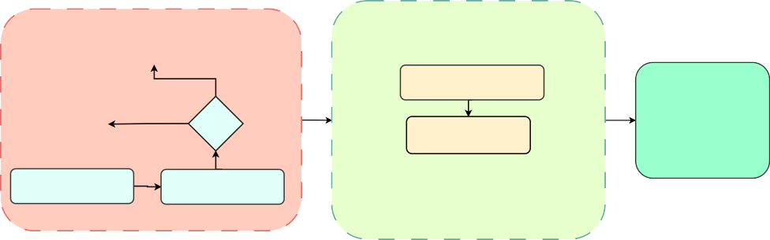
Dataset
(Indian-BhED / IndiBias)
Stage 2 — counterfactual augmentation and balancing
Stage 1 — counterfactual situation testing
Compare Prediction (Original Vs Counterfactual)
Swap Identity Markers (Name, Caste etc.)
Clean, balanced dataset (Debiased training data)
Generate samples
Swap identity, keep label
Prediction Changed?
Yes
Relabel / Remove
Check group distribution
Per demographic group
NO
Corrected Dataset
Figure 5: Pipeline for Bias Mitigation in Textual Data

- IndiBias ([16]) — seven axes of Indian social bias in English and Hindi, 800 sentence pairs.

Mathematical Proof and Theoretical Foundation

Let

D = {(x_{i}, a_{i}, y_{i})}^{N}
i=1

(8)

denote the dataset, where x_{i} ∈ R^{d} represents the feature vector, a_{i} ∈ {0, 1} is the binary pro-tected attribute, and y_{i} ∈ {0, 1} is the ground-truth class label. The proposed framework seeks to learn a parameterized classifier f_{θ} that maximizes predictive performance while minimizing demographic bias through a series of theoretical guarantees.

Counterfactual Fairness Constraint

To verify design validity prior to empirical execution, we define a counterfactual bias check at the individual level. Let x_{A←a} denote the feature profile of an instance x where the protected attribute is counterfactually set to a. The counterfactual bias score B(x) is formulated as:
B(x) = P (Yˆ = 1 | X = x_{A←a}) − P (Yˆ = 1 | X = x_{A←a}′ ) (9)

An individual instance is flagged as structurally biased whenever:

B(x) > τ_{b} (10)

Equations (9) and (10) guarantee that the pipeline programmatically isolates and targets in-stances whose predictions causally depend on the protected attribute.

Consensus-Based Noise Reduction Proof

Let C₁ and C₂ denote two independent classifier architectures trained on separate segments of the hypothesis space. The clean, consensus-verified subset is defined as:
S_{clean} = {x ∈ D | C₁(x) = C₂(x)} (11)

Assuming individual classification errors are conditionally independent given the true label y, let ϵ₁, ϵ₂ < 0.5 be the respective error rates of C₁ and C₂. The joint error probability within the agreement set satisfies:
P (C₁(x) = C₂(x) ̸= y) = ϵ₁ϵ₂ (12)
Because ϵ₁, ϵ₂ < 0.5, it strictly follows that:

ϵ₁ϵ₂ < min(ϵ₁, ϵ₂) (13)

Equation (13) provides analytical proof that S_{clean} possesses a strictly lower expected noise rate than either constituent classifier alone, validating our data cleaning pipeline.

Manifold-Preserving Synthetic Data Generation

To balance representation across demographic groups without introducing out-of-distribution noise, synthetic samples are restricted to local data manifolds. For a seed minority sample p and its nearest neighbors n₁, n₂, we compute the spatial distances:
x₁ = dist(p, n₁), x₂ = dist(p, n₂), x₃ = dist(n₁, n₂) (14) We establish inverse-distance interpolation weights to ensure localized fidelity:

x−1
x−1
x−1

a = ¹ , b = ² , c = ³ (15)
Ω Ω Ω
where Ω = x⁻¹ + x⁻¹ + x⁻¹, satisfying the convex constraints:
1 2 3
a + b + c = 1, and a, b, c ≥ 0 (16) The generated synthetic instance is given by:
x_{new} = a · p + b · n₁ + c · n₂ (17) By virtue of Eqs. (15)–(17), it is guaranteed that:
x_{new} ∈ Conv({p, n₁, n₂}) (18)

where Conv(·) denotes the convex hull. This ensures mathematically that synthetic generations stay bounded within the true local data manifold.

Distribution Alignment Objective
Let P₀(X|Y ) = P (X | Y, A = 0) and P₁(X|Y ) = P (X | Y, A = 1) represent the conditional feature distributions of the unprivileged and privileged groups, respectively. The alignment of these distributions is governed by minimizing the 2-Wasserstein distance metric:

min W₂ P_{θ}(X | Y, A = 0), P_{θ}(X | Y, A = 1) (19)
θ

By properties of optimal transport, achieving the global minimum implies:

W₂ → 0 =⇒ P (X | Y, A = 0) ≈ P (X | Y, A = 1) (20)

thereby eliminating statistical representation disparities between the groups.

Fairness-Constrained Optimization Learning
The overall framework formalizes the trade-off between classification objective L_{cls} and de-mographic parity metrics (Statistical Parity Difference, SPD; Equal Opportunity Difference, EOD):
min hL_{cls} + λ₁ · SPD + λ₂ · EODi (21)
f
subject to explicit boundary conditions:

SPD ≤ δ₁, and EOD ≤ δ₂ (22)

where λ₁, λ₂ are regularization parameters, and δ₁, δ₂ are user-defined empirical tolerances. To-gether, these five interconnected mathematical blocks prove the theoretical integrity and sound-ness of the design pipeline prior to validation testing.

Dissemination Plan

- Publish in top-tier venues: ICSE, FSE, FAccT, CVPR/ICCV, ACL/EMNLP, IEEE Trans-actions on Software Engineering.
- File patents for novel bias-correction algorithms in each modality.

- Release open-source toolkit on GitHub.

- Maintain a project repository on Github with datasets, code, and tutorials.

Time Schedule of Activities (Milestones)

Milestones

Objective 1: Tabular Bias Mitigation (Method 1) Objective 2: CV Bias Mitigation (Method 2) Objective 3: NLP Bias Mitigation (Method 3) Objective 4: Software Integration and Dissemination
    - Open-source toolkit.
    - Publications, patents, workshops, and seminars.

Time Schedule

References

- R. K. E. Bellamy, K. Dey, M. Hind, S. C. Hoffman, S. Houde, K. Kannan, P. Lohia,
J. Martino, S. Mehta, A. Mojsilovic´, S. Nagar, K. Natesan Ramamurthy, J. Richards,
D. Saha, P. Sattigeri, M. Singh, K. R. Varshney, and Y. Zhang. Ai fairness 360: An extensible toolkit for detecting and mitigating algorithmic bias. IBM Journal of Research and Development, 63(4/5):4:1–4:15, 2019.
- Joymallya Chakraborty, Suvodeep Majumder, and Tim Menzies. Bias in machine learning software: Why? how? what to do? In Proceedings of the 29th ACM joint meeting on European software engineering conference and symposium on the foundations of software engineering, pages 429–440, 2021.
- Ying Xiao, Jie M Zhang, Yepang Liu, Mohammad Reza Mousavi, Sicen Liu, and Dingyuan Xue. Mirrorfair: Fixing fairness bugs in machine learning software via coun-terfactual predictions. Proceedings of the ACM on Software Engineering, 1(FSE):2121–2143, 2024.
- Kewen Peng, Joymallya Chakraborty, and Tim Menzies. Fairmask: Better fairness via model-based rebalancing of protected attributes. IEEE Transactions on Software Engi-neering, 49(4):2426–2439, 2022.
- Hem Chandra Joshi and Sandeep Kumar. Fairgenerate: Enhancing fairness through syn-thetic data generation and two-fold biased labels removal. ACM Transactions on Software Engineering and Methodology, 2024.
- Hem Chandra Joshi and Sandeep Kumar. Fairpreprocessor: Better fairness via addressing imbalanced data through synthetic data generation and mitigating biased labels. IEEE Intelligent Systems, 2025.

- Ying Xiao, Shangwen Wang, Sicen Liu, Dingyuan Xue, Xian Zhan, Yepang Liu, and Jie M Zhang. Fairness is not just ethical: Performance trade-off via data correlation tuning to mitigate bias in ml software. arXiv preprint arXiv:2512.21348, 2025.
- Ching-Yao Chuang, Varun Jampani, Yuanzhen Li, Antonio Torralba, and Stefanie Jegelka. Debiasing vision-language models via biased prompts. arXiv preprint arXiv:2302.00070, 2023.
- Bowei Tian, Ruijie Du, and Yanning Shen. Fairvit: Fair vision transformer via adaptive masking. In European Conference on Computer Vision, pages 451–466. Springer, 2024.
- Ayesha Manzoor and Ajita Rattani. Fineface: Fair facial attribute classification leveraging fine-grained features. In International Conference on Pattern Recognition, pages 81–97. Springer, 2024.
- Shweta Patel and Dakshina Ranjan Kisku. Improving bias in facial attribute classifica-tion: A combined impact of kl divergence-induced loss function and dual attention. In International Conference on Pattern Recognition, pages 383–397. Springer, 2024.
- Kimmo Karkkainen and Jungseock Joo. Fairface: Face attribute dataset for balanced race, gender, and age for bias measurement and mitigation. In Proceedings of the IEEE/CVF winter conference on applications of computer vision, pages 1548–1558, 2021.
- Yan Luo, Min Shi, Muhammad Osama Khan, Muhammad Muneeb Afzal, Hao Huang, Shuaihang Yuan, Yu Tian, Luo Song, Ava Kouhana, Tobias Elze, et al. Fairclip: Harness-ing fairness in vision-language learning. In Proceedings of the IEEE/CVF conference on computer vision and pattern recognition, pages 12289–12301, 2024.
- Vijit Malik, Sunipa Dev, Akihiro Nishi, Nanyun Peng, and Kai-Wei Chang. Socially aware bias measurements for hindi language representations. In Proceedings of the 2022 Conference of the North American Chapter of the Association for Computational Linguis-tics: Human Language Technologies, pages 1041–1052, 2022.
- Khyati Khandelwal, Manuel Tonneau, Andrew M Bean, Hannah Rose Kirk, and Scott A Hale. Indian-bhed: A dataset for measuring india-centric biases in large language mod-els. In Proceedings of the 2024 International Conference on Information Technology for Social Good, pages 231–239, 2024.
- Nihar Sahoo, Pranamya Kulkarni, Arif Ahmad, Tanu Goyal, Narjis Asad, Aparna Garimella, and Pushpak Bhattacharyya. Indibias: A benchmark dataset to measure so-cial biases in language models for indian context. In Proceedings of the 2024 Conference of the North American Chapter of the Association for Computational Linguistics: Human Language Technologies (Volume 1: Long Papers), pages 8786–8806, 2024.

- Prashanth Vijayaraghavan, Soroush Vosoughi, Lamogha Chiazor, Raya Horesh, Roge-rio Abreu De Paula, Ehsan Degan, and Vandana Mukherjee. Decaste: Unveiling caste stereotypes in large language models through multi-dimensional bias analysis. arXiv preprint arXiv:2505.14971, 2025.
- ProPublica. propublica/compas-analysis: Data and analysis for ’machine bias’, 2015. Available at: https://github.com/propublica/compas-analysis (Ac-cessed: 2025-10-09).
- Professor Dr. Hans Hofmann. Statlog (german credit data), 2000. Available at: https://archive.ics.uci.edu/ml/datasets/Statlog+(German+ Credit+Data) (Accessed: 2025-10-09).
- UCI Machine Learning Repository. Heart disease data set, 2001. Available at: https:
//archive.ics.uci.edu/ml/datasets/Heart+Disease (Accessed: 2025-
10-09).

- P. Cortez and A. M. G. Silva. Student performance data set, 2014. https://archive.ics.uci.edu/ml/datasets/Student+Performance.
- UCI ML Repository. Bank marketing dataset, 2017.
https://archive.ics.uci.edu/ml/datasets/default+of+credit+card+clients.

- Agency for Healthcare Research and Quality (AHRQ). Medical expenditure panel survey (meps) 2015, 2015. https://meps.ahrq.gov/mepsweb/.
- I-Cheng Yeh. Default of credit card clients, 2016.
https://archive.ics.uci.edu/ml/datasets/default+of+credit+card+clients.

- Ronny Kohavi and Barry Becker. Adult (census income) dataset, 1994.
https://archive.ics.uci.edu/ml/datasets/Adult.

- Ziwei Liu, Ping Luo, Xiaogang Wang, and Xiaoou Tang. Deep learning face attributes in the wild. In Proceedings of the IEEE international conference on computer vision, pages 3730–3738, 2015.
- Jeremy Irvin, Pranav Rajpurkar, Michael Ko, Yifan Yu, Silviana Ciurea-Ilcus, Chris Chute, Henrik Marklund, Behzad Haghgoo, Robyn Ball, Katie Shpanskaya, et al. Chex-pert: A large chest radiograph dataset with uncertainty labels and expert comparison. In Proceedings of the AAAI conference on artificial intelligence, volume 33, pages 590–597, 2019.

